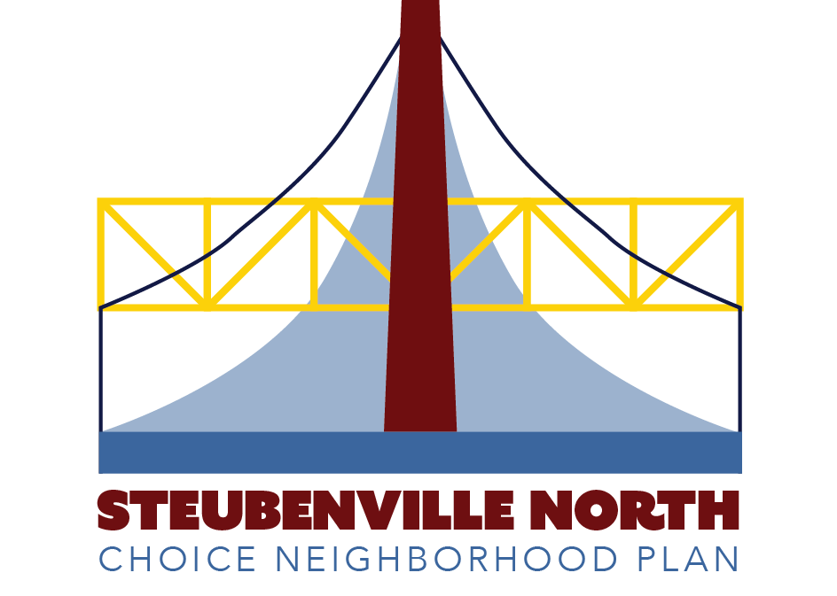
People Task Force Meeting
2/13/24
Choice Neighborhoods HQ

Input on Strategies and Partners/Resources
Participants used sticky stars to select the top 3 strategies in each People category. Then they brainstormed potential partners/resources who should be involved with high priority strategies.

Jobs and Economic Development
- High priority strategies
  - Partner with transportation providers and employers, including Amazon and others, to provide ride-share arrangements that help bring people to work and take them home. (8 stars)
Partners/resources
- Steel Valley Regional Transit Authority
- Funding available through the Ohio Department of Transportation’s Specialized Transportation Program authorized by Federal Transit Administration 49 USC Section 5310, which provides transportation for seniors and people with disabilities who are located in rural and small urbanized areas and need services beyond what is offered through conventional public transit service
- Walmart Distribution Center (Richmond, Wintersville, and Steubenville, OH)
- Amazon Warehouse (Imperial, PA)
- Rideshare via Uber / Lyft and local providers, e.g. Heavenly Rides Taxi Service
  - [Recognizing some parents work 12-hour shifts,] provide quality childcare, senior or disability care, and caregiver support options that operate at hours compatible with community needs. (8 stars)
Partners/resources
- Jefferson County Department of Job and Family Services
- Jefferson Metro Housing Authority
- Latch Key Programs associated with Steubenville City Schools - Neighborhood House Daycare and Preschool (423 South Street) may be an example
- Childcare providers, e.g. Stepping Stones Academy (816 N. 4th Street) and In His Hands Academy (238 N. 5th Street)
  - Bring employers to the North End who can offer permanent mid- and entry-level jobs. Work with others to provide temporary work opportunities plus youth and summer jobs or programs. (7 stars)
Partners/resources
- Jefferson County Chamber of Commerce
- Jefferson County Board of Commissioners
- City leadership, e.g. the City Council and City Manager
- Medium priority strategies
  - Match employment opportunities to residents’ skills, such as healthcare, customer service, computer skills, service/retail, building trades, and hospitality. Note: Amazon may be a good match for some residents. (5 stars)
  - Hire a social worker(s) who can help connect residents to resources, such as career coaching, small business training, and legal services. Jefferson Metro Housing Authority (JMHA) could apply to the Resilient Opportunity Self-Sufficiency (ROSS) Grant Program to fund the position. HUD offers to for public housing authorities with residents needing supportive services, resident empowerment activities, and assistance in becoming economically self-sufficient. In addition, JHMA recently won a HUD Family Self-Sufficiency (FSS) Program Grant. The money will enable JMHA to help residents secure jobs and become more economically self-sufficient, so they depend less on welfare and rental subsidies. ”FSS Coordinators in each local program build partnerships with employers and service providers in the community to help participants obtain jobs and services. These services may include childcare, transportation, basic adult education, job training, employment counseling, substance/alcohol abuse treatment, financial empowerment coaching, asset-building strategies, household skill training, homeownership counseling, and more.” (3 stars)
- Low priority strategies
  - Create a North End version of the Community Action Council (CAC) that has a diverse workforce and offers jobs that pay over CAC’s current rate of $11/hour. CAC currently provides utility assistance and computers to people applying for jobs. The organization’s current building is rental property, in poor condition, and needs to be modernized. It is also located outside the North End. (1 star)
  - Promote employment opportunities available at Amazon and other locations. (0 stars)
- Other comments
  - How will the removal of government housing and gradual replacement of housing in phases affect homelessness and transition into housing? What is the plan?
  - Transitional housing is a great need.
  - More opportunities/examples needed of granny flats/Accessory Dwelling Units (ADUs), which could be affordably bought or rented (instead of an apartment complex or room in a house).
Health
- High priority strategies
  - Build a grocery store that provides quality fresh produce. (13 stars)
Partners/Resources
- Urban Mission Ministries
- Steubenville Grocery Box
- Secure a trainer and develop a training program for future, homegrown grocery store owners/operators who sell fresh food.
- Identify a potential grocery drop-off point.
  - Develop and staff a pharmacy and medical clinic/urgent care in the neighborhood. (9 stars)
Partners/Resources
- Trinity Health Systems
- Tri-State Medical Center
- Identify existing pharmacy delivery zones used by A&B Sunset Pharmacy, Diamond Pharmacy, and Value Leader Pharmacy
- Ohio Valley Health Center (need space) - Acquire property and build a space for their services.
  - Provide greater access to healthcare professionals, especially those who are providing mental health counseling, so they can build stronger relationships and improve case management. (6 stars)
Partners/Resources
- Coleman Health Services, offering behavioral health, residential, employment and support services (short staffed)
- Integrated health service providers, e.g. Alliance Integrated Care, which offers both mental health and primary care services.
- Family Recovery Center, which provides addiction (drug and alcohol) and mental health services.
- Veteran’s Administration: DAV Vans and other vehicles transport people to and from medical appointments throughout the tri-state area of Ohio, Pennsylvania, and West Virginia along with New York.
- Trinity Health Systems’ Primetime Senior Services, which provides transportation services within and outside Jefferson County for doctor’s appointments. A person receiving services must be at least 60 years of age and a Jefferson County resident.
- Medium priority strategies
  - Develop a neighborhood farmers market. (5 stars)
  - Provide customized approaches to physical fitness that make use of trails, walking programs, and age-sensitive workouts. (2 stars)
  - Engage places of worship, encouraging them to participate in neighborhood activities. (2 stars)
- Note: St. Peter’s Catholic Church has over 1,300 parishioners every Sunday who should be involved in the neighborhood as part of the parish.
- Low priority strategies
  - Support the implementation of the Heritage Trail – Jefferson County has a grant to do the work. (1 star)

Safety
- High priority strategies
  - Improve the streets by providing proper sidewalks, more lighting, and street cleaning. (10 stars)
Partners/Resources
- Steubenville Public Works Department
  - Engage places of worship, encouraging them to participate in neighborhood activities. (7 stars)
Partners/Resources
- Reach out to active churches, e.g. Rev. Jason Elliott at the First Westminster Presbyterian Church who organizes the children’s / youth golf tournament.
- Mount Carmel Community Baptist Church
- Quinn Memorial African Methodist Episcopal Church
- Diocese of Steubenville
- Other church leaders
- Organize a “North End Pastors Association”
  - Develop a Safe Routes to School plan [that includes a “walking bus” and “bike bus” as healthy and fun options for students]. (4 stars)
Partners/Resources
- Steubenville City School
- Steubenville Police Department
- City of Steubenville
- Parents
- Medium priority strategies
  - Increase the frequency and visibility of neighborhood police patrols. (2 stars)
  - Improve neighborhood safety by installing better security cameras and utilizing community policing. (2 stars)
- Low priority strategies
  - Establish a Neighborhood Watch group to address issues of crime. (1 star)
  - Work with the Green Team to organize neighborhood cleanups, add trash cans, and educate residents about litter. (0 stars)

Education
- High priority strategies
  - Develop a partnership with the Public Library of Steubenville or Eastern Gateway Community College to provide a studying/tutoring “center” for adults and children. The center should provide internet and computer access. (9 stars)
Partners/Resources
- Public Library of Steubenville
- Eastern Gateway Community College
  - Design a family-oriented community center that includes computer rooms, tutoring, meal provision, and water recreation. Operate it at hours that work best for the neighborhood. (8 stars)
Partners/Resources
- Franciscan University
- Public Library of Steubenville
- Urban Mission Ministries (re: opportunity center)
- Ja’Quan Lavendar Foundation
- Royal Mayo (potential youth center at 7th and Franklin)
- Choice Neighborhood Ambassadors
  - Provide resources for quality shopping, housekeeping, [and home economics] assistance along with transportation. (6 stars)
Partners/Resources
- Jefferson County Department of Job and Family Services
- Jefferson County Housing Authority
- Jefferson County Vocational School (JVS)
  - Provide more education on budgeting, financial literacy, credit repair, and homeownership. (6 stars)
Partners/Resources
- Paramount Pursuits
- PNC Bank
- Credit unions, e.g. First Choice America Community Federal Credit Union (FCU) and Valley One Community FCU
- Millionaire’s Club (for students, teachers, or credit union sponsors

- Medium priority strategies
  - Make sure service providers, instructors, and teachers look like the community. (5 stars)
  - Provide a variety of programming for neighborhood youth. Examples should include arts, music, and after school along with sports and recreational activities. (5 stars)
  - Use a peer-to-peer educational approach to provide education on parenting skills and day-to-day family care. Offer the programs at the new neighborhood community center. [See 24/7 Moms and 24/7 Dad resources on parenting] (4 stars)
  - Match resources and educational programs to community needs for tutoring (GED and Adult High School Diploma), health-related services, and other needs. (3 stars).
  - Increase residents’ in-home access to the internet. (3 stars)
- Low priority strategies
  - Work with partners to improve digital literacy among residents. (0 stars)

“Specialized Transportation Program (5310).” Oho Department of Transportation. https://www.transportation.ohio.gov/programs/transit/transit-funding-resources/transit-specialized-transportation-program
“Family Self-Sufficency Program.” U.S. Department of Housing and Urban Development. https://www.hud.gov/program_offices/public_indian_housing/programs/hcv/fss
“DAV Vans: Transportation for Veterans.” U.S. Department of Veterans Affairs. https://www.va.gov/pittsburgh-health-care/dav-vans-transportation-for-veterans/

